

|  |  |
| --- | --- |
| MEAT substitute DATA ANALYSIS  predictive analytics report | |
| CONAGRA | |
| TeamSai Sugun Ravipalli Sampreethi Bokka Shruthi Srinivas | Bhavani Satish Bandi Tarun Gorle Jessica Mettu Guna Sourav Mosali |

# Contents

1. Market Research on Meat Consumption Trends
   1. Market Overview
   2. Key Trends
   3. Consumer Behavior and Preferences
   4. Challenges and Opportunities
   5. Major Players
   6. Market Position of Gardein
   7. Implications for Brands and Manufacturers
   8. Consumer Preferences
2. Visualizations
   1. Visualization 1 (Scatter plot for every region showing price per unit and unit sales)
   2. Visualization 2 (Histogram showing unit and base unit sales for every region)
   3. Visualization 3 (Stacked bar chart showing unit sales for every region)
   4. Visualization 4 (Distribution graph showing the price per volume and volume sales for every region)
   5. Visualization 5 (Pie chart showing base unit prices for every region)
3. Observations 
   1. Relationship between price per unit and unit sales in the South Central and Plains regions
   2. Unit sales increase despite higher prices in the north-east region
   3. Sales Trends in Plains and Central Regions (2020-2024)
   4. Variation in Unit Sales, Volume Sales, and Dollar Sales Across Product Categories
   5. Geographical Distribution of Sales Over Time
   6. Trend of ACV Weighted Distribution and its Correlation with Sales Performance
4. Inferences
   1. Strong Dollar Growth Trends
   2. Burger/Patty Dominance
   3. Significant Dollar Share Growth for Nuggets
   4. Preference for Regular Flavor
   5. Growth in Chicken Flavor
5. SWOT Analysis
   1. Strengths
   2. Weaknesses
   3. Opportunities
   4. Targets
6. Statistical Analysis of Meat Consumption Trends
   1. Year 2020
      1. Descriptive Statistics
      2. ANOVA Analysis
      3. Correlation Analysis
      4. Regression Analysis
      5. ANOVA Testing Conclusion
      6. Visualizations
   2. Year 2023
      1. Descriptive Statistics
      2. ANOVA Testing
      3. Correlation Analysis
      4. Regression Analysis
      5. Visualizations
7. [Multi-Year Analysis (2020 – 2024)](#_Multi-Year_Analysis_(2020)
   1. Descriptive Statistics
   2. Inference Analysis
   3. Correlation Analysis
   4. Hypothesis Testing (T-Test)
   5. Confidence Intervals for Regression Coefficients
   6. Visualizations
   7. ANOVA Analysis Conclusion
8. Conclusion

# Market Research on Meat Consumption Trends

This comprehensive market research report examines the details of meat consumption, offering valuable insights for industry stakeholders. The study involves data analysis using descriptive and visual statistics and trends on the given data.

## Market Overview

The meat substitutes market in the USA has seen significant growth in recent years, driven by increasing consumer awareness of health, environmental, and ethical concerns associated with animal agriculture. The market is characterized by various products made from soy, peas, mushrooms, and wheat, including plant-based burgers, sausages, nuggets, and more.

## Key Trends

**Health and Wellness:** Consumers are increasingly seeking meat substitutes as part of a healthier diet, looking for products that are high in protein but lower in calories, cholesterol, and saturated fat than traditional meat.

**Environmental Concerns:** The environmental impact of meat production is a major driver for the meat substitutes market, with consumers looking for more sustainable food options.

**Innovation and Product Development:** Companies continuously innovate to improve the taste, texture, and nutritional profile of meat substitute products, making them more appealing to a broader range of consumers.

**Mainstream Acceptance:** Meat substitutes are becoming more mainstream, with products now widely available in supermarkets, restaurants, and fast-food chains across the USA.

## Consumer Behavior and Preferences

The report explores consumer attitudes, perceptions, and purchasing decisions, uncovering influential factors such as health consciousness and sustainability concerns. A detailed analysis of regional variations sheds light on the impact of cultural, economic, and regulatory influences on meat consumption.

## Challenges and Opportunities

**Challenges**, including shifting consumer preferences and regulatory changes, are outlined, offering a strategic understanding for businesses.

**Opportunities** for growth and innovation, such as adapting to emerging trends and incorporating sustainable practices, are highlighted.

## Major Players

Some of the major players in the USA meat substitutes market include:

**Beyond Meat:** Known for its plant-based burgers and sausages, Beyond Meat is a leading meat substitute brand.

**Impossible Foods:** Famous for its Impossible Burger, this company has made significant inroads in the food service sector.

**Gardein (Conagra Brands):** Gardein offers various plant-based products, including burgers, meatballs, and chicken substitutes.

**Tofurky:** A long-standing brand in the market, Tofurky offers a variety of meatless products, including deli slices, sausages, and roasts.

## Market Position of Gardein

Gardein holds the fourth position in terms of dollar share within the Frozen (FZ) Meat Substitutes category. Despite being ranked fourth, Gardein is a significant player in the market, competing with established brands such as Morningstar Farms, Beyond Meat, and Impossible. Gardein's presence in the market indicates consumer acceptance and demand for its products, contributing to its market share and overall category sales.

## Implications for Brands and Manufacturers

Understanding flavor preferences and brand positioning is crucial for brands and manufacturers operating in the meat substitutes market. Brands can capitalize on the popularity of regular and chicken flavors by expanding their product lines and introducing innovative variations to meet diverse consumer tastes.

Additionally, brands can leverage insights from high-growth competitors like Impossible to inform their own product development and marketing strategies, ensuring relevance and competitiveness in the market.

Based on the information provided, Gardein holds the third-highest trip rate among buyers of Frozen (FZ) Meat Substitutes, indicating that consumers frequently shop for Gardein products within the category. Additionally, Gardein likely contributes to the average annual spending of approximately $60 per buyer in the FZ Meat Substitutes category.

Gardein's popularity and appeal to consumers, as evidenced by its trip rate and contribution to category spending, suggest that the brand has effectively positioned itself as a trusted and preferred choice for those seeking meatless alternatives.

## Consumer Preferences

**Taste and Texture:** Consumers prioritize products that closely mimic the taste and texture of traditional meat.

**Nutritional Profile:** Health-conscious consumers seek meat substitutes high in protein and low in saturated fats.

**Convenience:** Ready-to-eat and easy-to-prepare products are favored by busy consumers.

**Price:** While consumers are willing to pay a premium for plant-based products, price competitiveness remains a factor in purchasing decisions.

## Overview

The USA's meat substitutes market is expected to grow as consumer preferences shift towards plant-based diets. Innovation in product development and marketing strategies will be key for companies to differentiate themselves in this increasingly competitive market. This report equips industry stakeholders with actionable insights to navigate the evolving landscape of meat consumption, fostering informed decision-making and strategic planning for sustainable growth.

# Visualizations

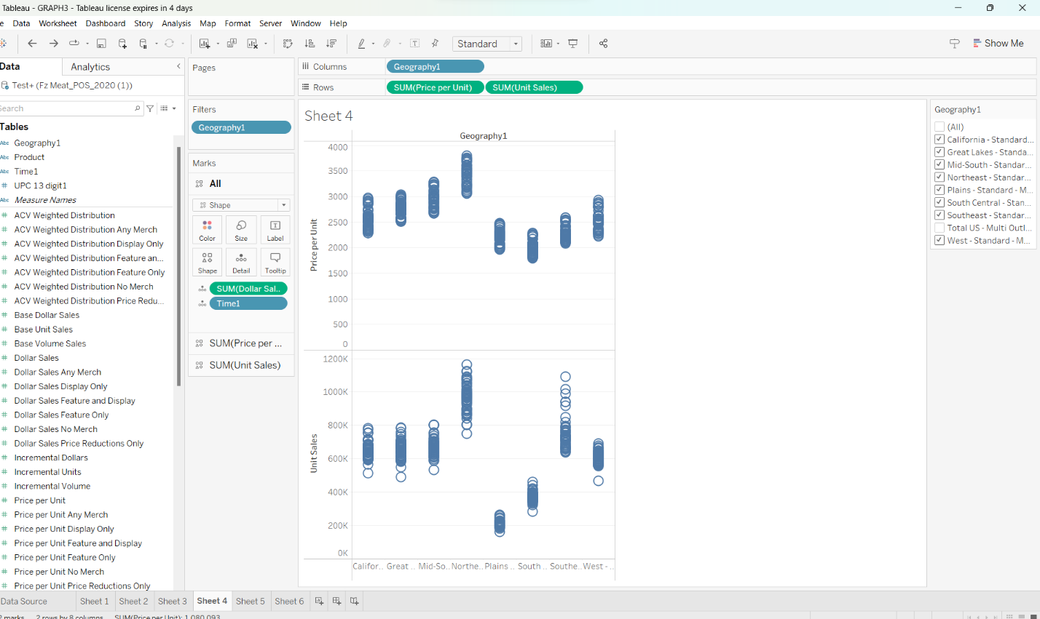

Figure Scatter plot for every region showing price per unit (top) and unit sales (bottom)

Figure Histogram showing the unit and base unit sales for every region

Figure Stacked bar chart showing unit sales for every region

Figure

***Vis. 4 (A distribution graph showing the price per volume and volume sales for every region)***

Figure A pie chart showing base unit prices for every region)

# Observations

## Relationship between **price per unit and unit sales** in the South Central and Plains regions

The analysis indicates that consumers in the South Central and Plains regions are highly price sensitive. As the price per unit increases, there is a corresponding decrease in unit sales.

The observed decrease in unit sales with higher prices may also be influenced by the competitive landscape in the South Central and Plains regions. If there are competing brands offering similar products at lower prices, consumers may choose those alternatives instead, leading to a decline in unit sales for Conagra Brands.

### Recommendations

Conagra Brands should consider optimizing pricing strategies in the South Central and Plains regions to better align with consumer preferences and market dynamics. This could involve conducting market research to understand price elasticity and identifying price points that maximize both sales volume and profitability.

Implementing promotional activities such as discounts, coupons, or bundle offers can help mitigate the impact of price increases on unit sales. By offering value-added promotions, Conagra can incentivize consumers to purchase their products even at higher price points, thereby maintaining or increasing sales volume.

## Analysis on increase in unit sales despite higher prices in the Northeast region

Consumers in the Northeast region may exhibit different purchasing behaviors compared to those in the South Central and Plains regions. They might prioritize factors other than price when making purchasing decisions, such as brand loyalty, product quality, or convenience. Therefore, they may be willing to pay higher prices for Conagra's products if they perceive them to offer superior value or meet their specific needs.

The competitive landscape and market conditions in the Northeast region could be favorable to Conagra Brands. If there are fewer competing brands offering similar products at lower prices, consumers may have limited alternatives, leading them to choose Conagra's products despite the higher prices.

### Recommendations

* Continue to focus on product quality, innovation, and differentiation to justify the higher prices in the Northeast region. Invest in research and development to introduce new and improved products that meet the evolving needs and preferences of consumers in this market.
* While unit sales are increasing despite higher prices in the Northeast region, it's essential to monitor market dynamics and consumer feedback continuously. Conduct periodic pricing analyses to ensure that price points remain competitive and aligned with consumer expectations while maximizing profitability.
* Explore opportunities to expand distribution channels and reach new segments of consumers in the Northeast region. Partner with retailers, e-commerce platforms, or specialty stores to increase accessibility and visibility of Conagra's products, further driving sales growth.
* By implementing these recommendations, Conagra Brands can capitalize on the favorable market conditions in the Northeast region and sustain the upward trend in unit sales despite higher prices, ultimately driving growth and profitability in this key market segment.

## Sales Trends in Plains and Central Regions (2020-2024)

Figure

***Vis. Sales trends in $ for Plains and Central regions***

This report analyzes the sales trends of the Plains and Central regions over a five-year period from 2020 to 2023. The focus is on understanding the performance of these regions and identifying any notable trends or patterns in sales data.

### Key Findings

Central Region: Sales in the Central region exhibited consistent growth throughout the entire period, showing an upward trajectory each year.

### Plains Region

Sales in the Plains region experienced a slight decrease in 2021 compared to the previous year. However, sales rebounded in subsequent years, with a gradual increase observed until 2023.

### Analysis and Interpretation

The sales trends in both regions reveal distinct patterns. While the Central region demonstrated consistent growth year over year, the Plains region experienced a temporary setback in 2021 followed by a recovery. These findings suggest differing market dynamics and potential factors influencing sales performance in each region.

### Implications and Recommendations

**Central Region:** Given the consistent growth observed in the Central region, it may be beneficial to allocate additional resources and marketing efforts to further capitalize on this trend.

**Plains Region:** Strategies should be devised to address the slight decline in sales experienced in 2021 and sustain the positive momentum observed in subsequent years.

Further analysis is warranted to identify the specific factors contributing to fluctuations in sales within the Plains region.

## Variation in Unit Sales, Volume Sales, and Dollar Sales Across Product Categories

Figure

***Vis. Unit sales in $ across product categories***

### **Analysis**

* The top product across all four years is consistently Banquet Brown N Serve Frozen Breakfast Sausage, which maintained its leading position in terms of unit sales.
* Similarly, the second top product across all four years is consistently Private Label Frozen Alligator Filet, which also maintained a significant level of unit sales, albeit slightly lower than the top product.
* Both products exhibit relatively stable unit sales over the years, with Banquet Brown N Serve Frozen Breakfast Sausage showing a slight increase in unit sales from 2020 to 2021 and 2023, and Private Label Frozen Alligator Filet experiencing slight fluctuations.

### Conclusion

* The analysis indicates the consistent popularity and sales performance of Banquet Brown N Serve Frozen Breakfast Sausage and Private Label Frozen Alligator Filet as the top products across the years 2020 to 2023.
* These products demonstrate strong market demand and may represent key opportunities for further exploration and strategic planning within their respective product categories.

## Geographical Distribution of Sales Over Time:

Figure

***Vis. Geographical distribution of unit sales from 2020 - 2023***

### Analysis:

* The South-Central region consistently recorded higher volume sales compared to the Plains region across all four years.
* In 2020, the South-Central region had significantly higher volume sales compared to the Plains region.
* Although the volume sales decreased in both regions from 2020 to 2021, the South-Central region continued to maintain a higher sales volume compared to the Plains region.
* The sales volume decreased further in both regions from 2021 to 2022, with the South-Central region still leading in volume sales.
* In 2023, while the volume sales decreased in both regions compared to the previous year, the South-Central region remained ahead in terms of volume sales.

### Conclusion:

* The analysis highlights the geographical distribution of sales over time, with the South-Central region consistently outperforming the Plains region in terms of volume sales across the years 2020 to 2023.
* Understanding these regional sales dynamics can inform strategic decision-making and resource allocation to maximize sales opportunities within each region.

## Trend of ACV Weighted Distribution and its Correlation with Sales Performance:

Figure

***Vis. ACV weighted distribution vs volume sales***

### Analysis

* The correlation coefficient between ACV weighted distribution and volume sales increased slightly from 2022 (0.554) to 2023 (0.582), indicating a strengthening correlation between these two variables.
* The ACV weighted distribution also increased from 2,14,360 in 2022 to 2,15,108 in 2023.
* Despite the increase in ACV weighted distribution, there was a slight decrease in volume sales from 7,82,95,929 in 2022 to 7,78,94,581 in 2023.

### Conclusion

* The trend of ACV weighted distribution shows an increase from 2022 to 2023, indicating potential efforts to expand product distribution or increase market presence.
* The correlation coefficient suggests a moderately positive correlation between ACV weighted distribution and volume sales, indicating that as ACV weighted distribution increases, volume sales also tend to increase, albeit with some variation.
* Further analysis may be required to understand the factors contributing to the observed changes in volume sales despite the increase in ACV weighted distribution, allowing for informed decision-making and strategic planning to optimize sales performance.

## Top products to focus on Plains and South–Central region by unit sales ($)

Figure

Table Products to focus on in Plains and South-Central region

|  |  |
| --- | --- |
| **Row Labels** | **Sum of Sales ($)** |
| PURNELL OLD FOLKS FROZEN PORK COUNTRY SAUSAGE REGULAR 38 OZ | 1502889.217 |
| FAST FIXIN FROZEN BEEF STEAK RESEALABLE PLASTIC BAG 22.75 OZ | 940381.8271 |
| JIMMY DEAN FROZEN PORK AND TURKEY SAUSAGE ORIGINAL 23.9 OZ | 664301.6321 |
| BANQUET BROWN N SERVE FROZEN PORK AND TURKEY BREAKFAST SAUSAGE ORIGINAL 32 OZ | 568398.5711 |
| GARYS QUICK STEAK FROZEN BEEF STEAK VACUUM PACKED 10.8 OZ | 509411.5127 |

Despite the unit sales loss, the top meat products are showing increased demand and sales in the Conagra market.

The identified top-performing meat products in the Plains and South-Central regions present a strong foundation for Conagra's growth in the Meat Substitutes category. By leveraging these insights and implementing strategic recommendations, Conagra can position itself for success in this evolving market. Continued data-driven analysis and adaptation to changing consumer trends will be key to unlocking the full growth potential in the Meat Substitutes category.

Figure Major revenue share is contributed by the Top 5 meat products

Figure Product performance from 2020 – 2024 using average Base Dollar Sales

# Inferences

## Strong Dollar Growth Trends:

**Over the past three years, the Meat Substitutes category has experienced robust dollar growth, indicating increased consumer spending on meat alternative products.**

This growth suggests a growing market demand for meat substitutes, potentially driven by factors such as health consciousness, environmental concerns, and changing dietary preferences.

## Burger/Patty Dominance:

**Burger/Patty products constitute over 25% of the total sales within the Meat Substitutes category.**

This indicates that burgers and patties are among the most popular and widely consumed types of meat substitute products.

The popularity of burger/patty products may be attributed to their versatility, as they can be used as standalone meals, in sandwiches, or incorporated into various recipes.

## Significant Dollar Share Growth for Nuggets:

**Nuggets have experienced the highest dollar share growth among all product types within the Meat Substitutes category.**

This suggests an increasing consumer demand for nugget-style meat substitute products.

The growth in dollar share indicates that nuggets are gaining traction in the market and are becoming a significant contributor to overall category sales revenue.

The popularity of nugget products may stem from their convenience, appealing texture, and suitability for various eating occasions, including snacking and meal accompaniments.

## Preference for Regular Flavor:

**Regular flavor products constitute over 34% of total category sales.**

This indicates that consumers have a strong preference for traditional or standard flavors when purchasing meat substitute products. Regular flavors are likely perceived as versatile and familiar, appealing to a broad range of consumers who may be transitioning to meat alternatives or seeking familiar tastes in plant-based options.

## Growth in Chicken Flavor:

**Growth within the regular flavor category is specifically attributed to chicken-flavored products.**

This suggests an increasing demand for chicken-flavored meat substitute products, possibly driven by consumers seeking alternatives to traditional poultry products.

The growth in chicken-flavored options underscores the importance of variety and innovation within the meat substitutes market to cater to evolving consumer preferences.

# SWOT Analysis

## Strengths

**Brand Recognition:** Conagra's Gardein brand is a well-established name in the meat substitutes market. This recognition helps build consumer trust and loyalty, providing a competitive edge over newer or lesser-known brands.

**Product Variety:** Gardein offers a diverse range of meat substitute products, including plant-based burgers, meatless meatballs, chicken substitutes, and fishless filets. This variety caters to different consumer tastes and dietary preferences, allowing the brand to capture a broader market segment.

**Quality and Taste:** Conagra has invested in developing products that closely mimic the taste and texture of real meat. This focus on quality and taste has helped attract consumers looking for plant-based alternatives without compromising on sensory experiences.

**Research and Development:** Conagra's commitment to research and development enables continuous innovation in product offerings. This includes improving the nutritional profile of products, enhancing taste and texture, and exploring new plant-based **ingredients**.

**Sustainability:** With growing consumer awareness of environmental issues, Gardein's plant-based products align with the trend towards sustainability and ethical eating. This can be a strong selling point for environmentally conscious consumers.

## Weaknesses

**Price Sensitivity:** Meat substitutes, including Gardein's products, are often priced higher than their meat counterparts. This price premium can deter price-sensitive consumers and limit market penetration, especially in price-sensitive markets.

**Dependency on Retail Channels:** Conagra's meat substitutes are primarily sold through retail channels, making the brand vulnerable to fluctuations in retail market conditions, such as changes in consumer shopping habits or retail consolidation.

**Limited Presence in Emerging Markets:** While Gardein has a strong presence in developed markets, its penetration in emerging markets is limited. This restricts the brand's growth potential in regions with rising demand for meat substitutes.

## Opportunities

**Growing Demand for Plant-Based Products:** The global shift towards plant-based diets presents a significant opportunity for Conagra to expand its market share. Increasing awareness of health, environmental, and ethical concerns drive more consumers to seek meat alternatives.

**Product Innovation:** There is a continuous opportunity for innovation in the meat substitutes market. Conagra can leverage its R&D capabilities to develop new flavors, textures, and nutritionally enhanced products that cater to evolving consumer preferences.

**Global Expansion:** Expanding Gardein's distribution into emerging markets can tap into the growing demand for plant-based products in these regions. This expansion can drive growth and increase the brand's global market share.

**Partnerships and Collaborations:** Collaborating with food service providers, restaurants, and other food brands to offer meat substitute options can increase brand visibility and accessibility. This can also help in reaching new consumer segments.

**E-commerce Growth:** The increasing trend of online grocery shopping presents an opportunity for Conagra to enhance its distribution strategy. Investing in e-commerce platforms can improve product accessibility and drive sales.

## Threats

**Intense Competition:** The meat substitutes market is becoming increasingly competitive, with numerous new entrants and established food companies expanding their plant-based offerings. This competition can lead to price wars, reduced market share, and the need for continuous innovation to stay relevant.

**Regulatory Challenges:** Changes in regulations related to labeling and marketing of plant-based products can impact on the meat substitutes market. For example, restrictions on using "burger" or "sausage" for plant-based products can affect branding and consumer perception.

**Supply Chain Vulnerabilities:** Fluctuations in the availability and price of raw materials, such as soy or peas, can affect production costs and profitability. Supply chain disruptions, such as those caused by pandemics or climate events, can also impact product availability.

**Consumer Preferences:** Shifts in consumer preferences, such as a move back towards animal-based proteins or concerns about processed foods, could impact demand for meat substitutes. Keeping up with changing consumer trends is crucial for maintaining market share.

**Economic Downturns:** Economic downturns can reduce consumer spending on premium-priced products like meat substitutes. This can affect sales and profitability, especially in markets where price sensitivity is high.

# STATISTICAL ANALYSIS of Meat Consumption Trends

## YEAR 2020

### Statistical Summary

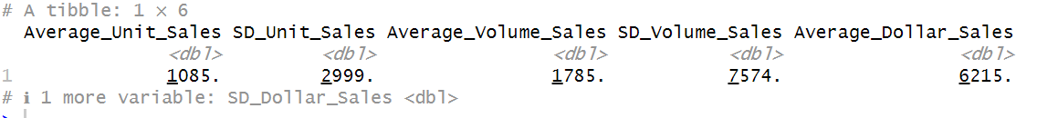

Figure

### Descriptive Statistics

Figure

### ANOVA Analysis

Figure

**Product:** The ANOVA result for the Product variable is highly significant (p-value < 2e-16), indicating that there is a statistically significant difference in Dollar Sales among different products. The F value of 117.0 supports this significance, suggesting a strong product effect on sales.

**Geography:** The geography variable also shows a highly significant effect on Dollar Sales (p-value < 2e-16) with an F value of 782.9. This indicates that sales significantly differ across geographic regions. The large difference in degrees of freedom (903 for Product and 1 for Geography) reflects the number of levels or groups within these variables, with Product having many unique values.

The significant results for both factors suggest that both product type and geography play crucial roles in influencing sales outcomes.

### Correlation Analysis



The correlation coefficient between Dollar Sales and Volume Sales is 0.5777248. This indicates a moderate positive linear relationship between the two variables. As Volume Sales increases, Dollar Sales also tend to increase.

### Regression Analysis

Figure

The regression analysis with Dollar Sales as the dependent variable and Volume Sales as the independent variable reveals a significant relationship (p-value < 2e-16 for Volume Sales). The positive estimate (coefficient) for Volume Sales (0.6043) suggests that for every one unit increase in Volume Sales, Dollar Sales increase by approximately 0.6043 units, holding other factors constant.

The intercept, although significantly different from zero, indicates that if Volume Sales were zero, Dollar Sales would be at -7065 units, which might not have a practical interpretation in this context and could indicate the model's limitations in predicting sales at very low volumes.

The model explains about 27.2% of the variability in Dollar Sales (Multiple R-squared: 0.272), which is a decent amount but also indicates that other variables not included in the model may account for the remaining variability in Dollar Sales.

The Residual Standard Error (RSE) of 13880 on 54948 degrees of freedom suggests variability in the Dollar Sales predictions made by the model. The residuals' spread (-19535 to 364403) indicates some large deviations from the model, especially considering the presence of outliers or extreme values in Dollar Sales.

### ANOVA Test Conclusion

Product and Geography significantly influence Dollar Sales, with varying degrees of sales across different products and geographical regions. The positive correlation and regression relationship between Volume Sales and Dollar Sales indicate that as volume sales increase, dollar sales tend to increase as well.

### Visualizations

Figure

Vis. 1

Figure

Vis. 2

## YEAR 2023

### Statistical summary

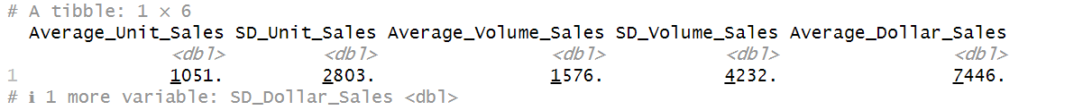

Figure

### Descriptive statistics

Figure

### ANOVA Test

Figure

* Both Product and Geography have a significant effect on the response variable, as indicated by the very low p-values (<2e-16).
* The F-statistic is high, suggesting that at least one of the predictors significantly influences the target variable.
* Both Product and Geography are significant predictors of the response variable.
* The model is statistically significant.

### Correlation Analysis



The correlation coefficient is 0.9355116, indicating a very strong positive linear relationship between Volume Sales and Dollar Sales. There is a very strong positive correlation between Volume Sales and Dollar Sales.

### Regression Analysis

Figure

* The linear regression model is represented as Dollar Sales = 627.90275 + 4.32663 * Volume Sales.
* Both intercept and slope coefficients are highly significant (p-values < 2e-16).
* The model explains a substantial amount of the variability in Dollar Sales (Adjusted R-squared: 0.8752).
* The intercept and slope coefficients are highly significant.
* The model is statistically significant, and it explains a large proportion of the variability in Dollar Sales.

### Visualizations

Figure

Figure

# Multi-Year Analysis (2020 – 2024)

## Descriptive Statistics

Figure

### Statistical Summary

Figure

### Descriptive Statistics

Figure

## Inferential Statistics

### ANOVA Test

Figure

The ANOVA test shows a significant effect of Geography on Dollar Sales, with a very low p-value (<2e-16), indicating strong evidence against the null hypothesis of no difference between geographical groups in terms of dollar sales. The F-value of 1247 further suggests a large variance between the groups compared to within the groups.

### Regression Analysis

Figure

The regression model including both Volume Sales and Geography as predictors of Dollar Sales is highly significant, with an F-statistic of about 1.404e+05 and a p-value < 2.2e-16. This indicates a very strong linear relationship between the predictors and the outcome variable.

For every unit increase in Volume Sales, Dollar Sales increase by approximately 2.589 units, holding geography constant.

The coefficient for Geography of South Central - Standard - Multi Outlet + Conv suggests that, holding volume sales constant, dollar sales in the South-Central geography are, on average, 593.6 units higher than the baseline geography (likely Plains - Standard - Multi Outlet + Conv, assuming it's the reference category).

The model explains about 57.16% of the variance in Dollar Sales (Multiple R-squared: 0.5716), which is a substantial proportion, indicating a good fit.

### Correlation Analysis



The correlation coefficient of 0.7558494 between Volume Sales and Dollar Sales indicates a strong positive linear relationship. As volume sales increase, dollar sales also increase.

### Hypothesis Test (t-test)

Figure

The Welch Two Sample t-test provides strong evidence (p-value < 2.2e-16) to reject the null hypothesis of equal means in dollar sales between the two geographies. The negative t value and the confidence interval for the difference in means (ranging from -2969.495 to -2645.487) suggest that the mean dollar sales in the South-Central geography are significantly higher than in the Plains geography.

### Confidence Intervals for Regression Coefficients

Figure

The confidence intervals for the regression coefficients provide a range of plausible values for each parameter in the population. For instance, the 95% confidence interval for the slope of Volume Sales suggests that with 95% confidence, the increase in dollar sales per unit increase in volume sales is between 2.579 and 2.599.

### Visualizations

Figure

Vis. 5

Figure

Vis. 6

Figure

Vis. 7

### ANOVA Test Conclusion

This comprehensive analysis reveals significant geographical differences in dollar sales, with South Central - Standard - Multi Outlet + Conv geography showing higher average sales than the baseline (likely Plains). The strong positive correlation and regression analysis indicate that volume sales are a significant predictor of dollar sales, with geography also playing a crucial role. The regression model's significant F-statistic and high R-squared value suggest a good fit for predicting dollar sales based on these predictors. These findings could inform targeted marketing strategies, sales forecasting, and resource allocation to optimize sales performance across different geographies.

**Histograms using multiple variables:**

Histograms using multiple variables typically involve visualizing the distribution of each variable individually while also considering their relationship with one another.

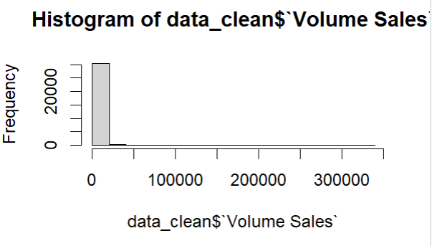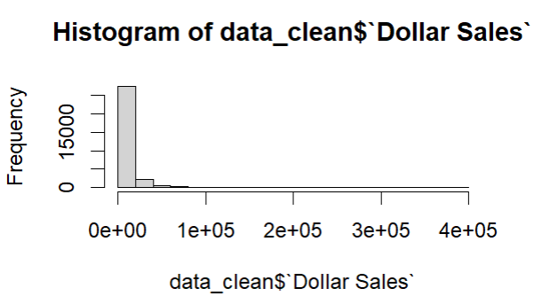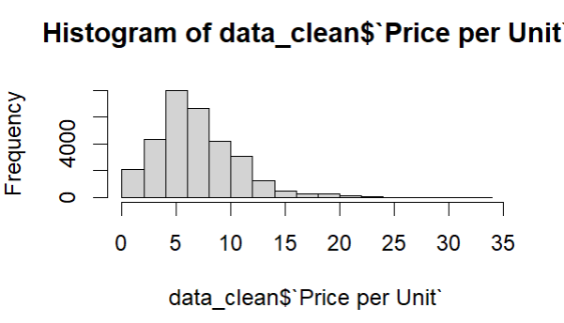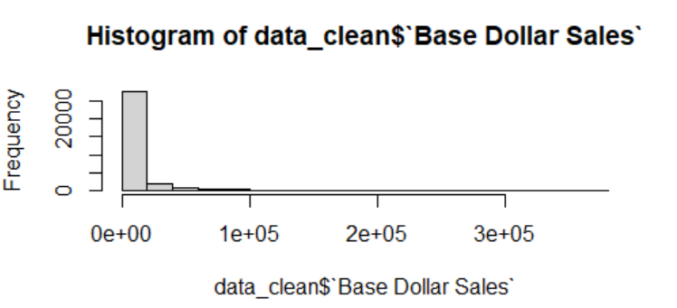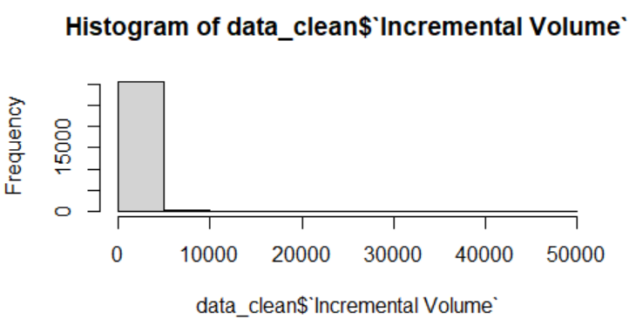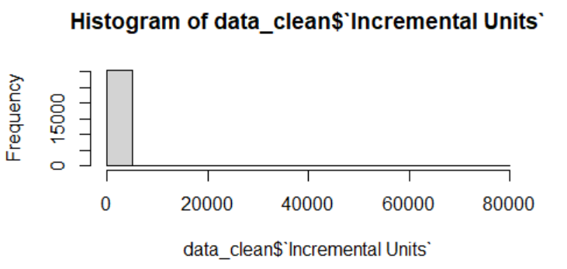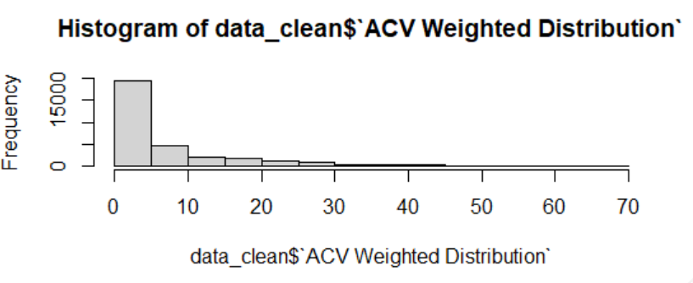

Plots using multiple variables:

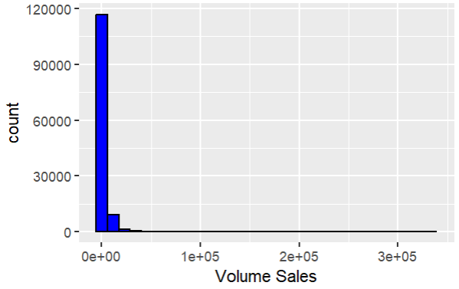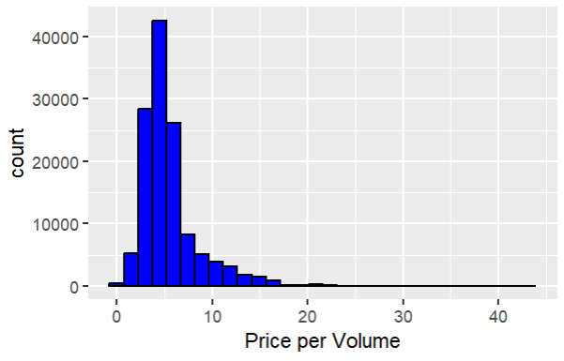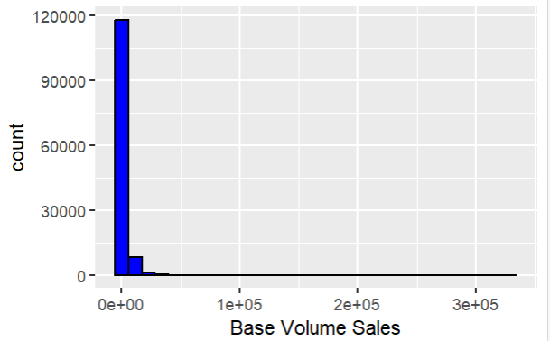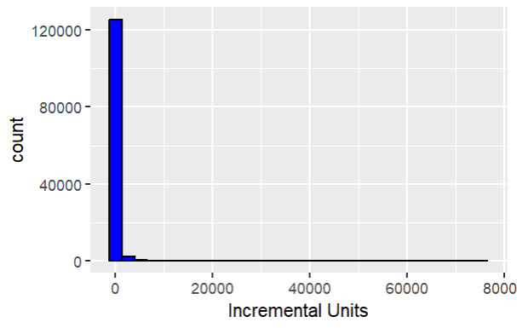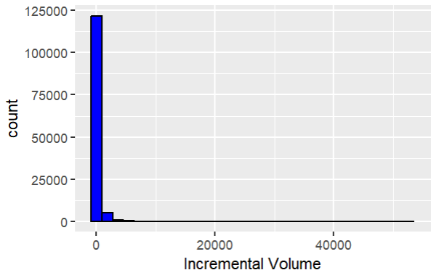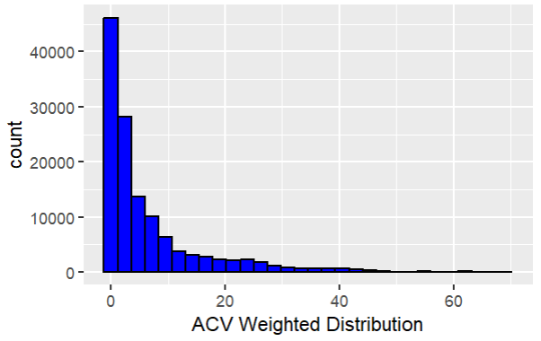

Heat Map

Correlation matrix

Linear Regression Model

These analyses provide valuable insights into the distribution, relationships, and predictive factors affecting sales performance.

# Regression Analysis

## Different regions, product categories, and sales

Figure

Figure

Figure

### Interpreting the results:

* R-squared (0.585) indicates that approximately 58.5% of the variance in Dollar Sales can be explained by the model.
* ACV Weighted Distribution (874.1859): For each one-unit increase in ACV Weighted Distribution, there is an associated increase of approximately $874 in Dollar Sales.
* Being in the Northeast is associated with an increase in Dollar Sales by approximately $2629 compared to the baseline (California region).
* 'Category_Chicken' and ‘Category_Veggie’ has a negative coefficients (-1813.0686 and -1942.65 respectively) which means Chicken and Veggie products are associated with a decrease in Dollar Sales by approximately $1813 and $1942 respectively compared to the baseline category (Category_Nuggets).

## ACV weighted distribution of different regions and sales ($)

OLS regression for each geographic region to determine the impact of ACV Weighted Distribution on Dollar Sales for that specific region.

Figure

### Interpreting the results

|  |  |  |  |  |
| --- | --- | --- | --- | --- |
| Geographic Region | R-squared | ACV Weighted Distribution Coefficient | | P-value |
| California - Standard - Multi Outlet + Conv | 56.5% | | $902.82 | 0.000 |
| Great Lakes - Standard - Multi Outlet + Conv | 64.7% | | $822.64 | 0.000 |
| Mid-South - Standard - Multi Outlet + Conv | 65.4% | | $929.94 | 0.000 |
| Northeast - Standard - Multi Outlet + Conv | 59.7% | | $1254.35 | 0.000 |
| Plains - Standard - Multi Outlet + Conv | 72.8% | | $403.75 | 0.000 |
| South Central - Standard - Multi Outlet + Conv | 74.3% | | $600.91 | 0.000 |
| Southeast - Standard - Multi Outlet + Conv | 57.4% | | $955.90 | 0.000 |
| West - Standard - Multi Outlet + Conv | 63.3% | | $766.90 | 0.000 |

### Summary

Increasing ACV Weighted Distribution in each region is associated with higher Dollar Sales, making it an important factor to consider in marketing and distribution strategies.

## Impact of price reductions and promotional offers on sales ($)

OLS regression for each Pricing and ACV related columns to determine the impact on Dollar Sales for that specific region.

Figure

Figure

Figure

### Interpretations

* **Price per Unit -1577.32**: For every unit increase in price per unit, dollar sales decrease by approximately 1577.32, suggesting a negative relationship between price and sales volume.
* **Price per Unit No Merch 1974.23**: Indicates a positive relationship; sales increase by about 1974.23 when there is no merchandising activity, perhaps suggesting higher baseline prices or value perception in scenarios without promotions.
* **Price per Unit Any Merch 1722.57**: Also shows a positive effect on sales, increasing by approximately 1722.57, which might indicate effective merchandising strategies that boost sales.
* **Price per Unit Price Reductions Only 182.35**: A smaller positive impact compared to other merchandising strategies, suggesting that price reductions alone have a lesser impact on sales than other types of merchandising included in the model.
* **ACV Weighted Distribution 1901.54**: A significant positive coefficient, indicating that an increase in distribution weighted by ACV (Adjusted Contract Value) tends to increase sales significantly.

### Summary

Overall, your model indicates significant relationships between various types of pricing and merchandising strategies and dollar sales. The model's effectiveness, as measured by R-squared, is moderate, suggesting that other factors not included in the model might also significantly influence dollar sales. The statistically significant F-test implies that the model is a good fit for the data compared to a model with no independent variables.

# Recommended Marketing Strategies for Conagra in the Meat Substitute Market

### Focus on Regional ACV Weighted Distribution Enhancements:

Increase the Adjusted Contract Value (ACV) Weighted Distribution in key regions, especially those with higher R-squared values indicating strong model predictions such as the Plains (72.8%) and South Central (74.3%). This suggests that enhancing distribution channels and increasing shelf presence in these regions could significantly boost Dollar Sales.

### Optimize Pricing Strategies Based on Product Categories and Merchandising:

Re-evaluate and possibly adjust pricing strategies for different categories. Given the negative impact of increased prices on Dollar Sales (**Price per Unit: -1577.32**), consider adopting more competitive pricing, especially for Chicken and Veggie products which showed negative coefficients, thereby reducing their sales.

Leverage promotional strategies effectively. The positive coefficients for **Price per Unit No Merch** and **Price per Unit Any Merch** suggest that merchandise-related promotions are associated with increased sales. However, strategies should be customized: focus on non-merchandising promotions where they already perform well, and boost merchandising efforts where needed.

### Tailored Regional Promotions:

Implement targeted promotional offers in regions where ACV Weighted Distribution has a significant impact on sales. For instance, the Northeast region, with the highest coefficient for ACV Weighted Distribution (**$1254.35**), may benefit from increased promotional activities and customized marketing campaigns to further leverage this high impact on sales.

## Rationale for Recommended Strategies:

* **Data-Driven Decisions**: The regression results provide clear evidence that both pricing and distribution strategies are crucial levers in influencing sales. By focusing on these aspects, Conagra can make informed decisions that are likely to result in positive outcomes.
* **Regional Focus**: Different regions show different sensitivities to distribution efforts. Focusing on regions where the ACV Weighted Distribution has a higher coefficient ensures that marketing efforts yield the maximum return on investment.
* **Pricing Sensitivity**: The analysis shows that sales are sensitive to price changes. By adjusting prices strategically and using promotions wisely, Conagra can manage consumer perception and demand effectively.

## Expected Returns for Conagra:

* **Quantitative Impact**: Increasing ACV Weighted Distribution, particularly in high-impact regions, is expected to directly increase sales. For instance, every unit increase in ACV Weighted Distribution leads to a significant increase in Dollar Sales. This suggests that enhancing distribution could lead to proportional increases in sales figures, potentially translating into millions of dollars in additional revenue.
* **Qualitative Impact**: By adopting a more tailored approach to pricing and promotions, Conagra is likely to see improved brand perception and customer loyalty. Competitive pricing and effective promotional strategies can enhance the brand’s value proposition in the meat substitute market, leading to long-term gains in market share and customer base.
* **Overall Market Performance**: Implementing these strategies is expected to not only improve immediate sales figures but also strengthen Conagra’s market position in the rapidly growing meat substitute segment. Enhanced distribution and optimized pricing strategies will likely contribute to a stronger competitive edge and higher overall market performance.

In summary, by strategically enhancing distribution and optimizing pricing and promotional strategies based on solid, data-driven insights, Conagra can expect to see both immediate and long-term improvements in sales and market performance in the meat substitute market.

# Conclusion

The Meat Substitutes market presents significant opportunities for growth and innovation, fueled by changing consumer preferences, increasing health consciousness, and environmental awareness. By understanding consumer behavior, market dynamics, and emerging trends, Conagra can position itself as a leader in the category and capitalize on the growing demand for meat substitute products. By diversifying its product portfolio, optimizing pricing strategies, and implementing targeted marketing initiatives, Conagra can enhance its competitive advantage and drive sustainable growth in the rapidly evolving Meat Substitutes market.

Finally, the thorough examination of the Plains and Central regions' sales trends from 2020 to 2023 sheds important light on the characteristics of these markets. Interestingly, sales in the Central region showed a steady increase trend during the studied period, while the Plains region had a brief decrease in 2021 that was followed by a subsequent recovery.

Two goods consistently performed at the top of the analysis: Banquet Brown N Serve Frozen Breakfast Sausage and Private Label Frozen Alligator Filet. This indicates that there is a significant market demand for these products and that there is need for more strategic research into them. Comprehending the aforementioned market dynamics is essential for efficiently allocating resources and devising strategic plans to leverage expansion prospects.

Additionally, the sales distribution map demonstrated how the South-Central region consistently outperformed the Plains region in volume sales during the course of the study. This highlights how crucial regional subtleties are in directing policies for allocating resources and making decisions. ACV weighted distribution and volume sales also showed a somewhat positive link, according to the data, indicating that broadening product distribution or boosting market presence could have a favorable effect on sales performance. To identify the underlying causes of the observed variances in sales, more research is necessary.

Finally, the Plains and South-Central regions' top-performing meat products provide Conagra with promising development prospects in the Meat Substitutes category. Conagra must take use of these insights and put strategy recommendations into practice if it hopes to seize market opportunities and position itself for success in these evolving markets.

For Conagra to realize the full development potential of the Meat Substitutes category and propel overall business success in the years to come, it will be essential to maintain its focus on data-driven research and flexibility in response to changing consumer preferences.